### Detailed Documentation

#### 1. ****Introduction****

#### In this project, we develop a program that processes a single-block SQL query by applying heuristic optimizations. The goal is to improve the execution efficiency of the input SQL query by converting it into an optimized query tree and then refining it back into SQL.

#### Project Overview

The objective of this project is to develop a program that processes a single-block SQL query by applying heuristic optimizations to improve execution efficiency. The program will:

1. Parse the input SQL query.
2. Generate an initial canonical query tree.
3. Apply heuristic optimizations to the query tree.
4. Output the initial and optimized query trees.
5. Convert the optimized query tree back to a refined SQL query.

#### Code Description

The code consists of several key components:

**QueryNode Class:**

* 1. Represents a node in the query tree.
  2. Contains the operation (SELECT, FROM, WHERE, JOIN, etc.) and its children nodes.

**SQLQueryOptimizer Class:**

* 1. Handles the parsing of the SQL query and the construction of the query tree.
  2. Applies heuristic optimizations to the query tree.
  3. Converts the optimized query tree back to SQL.

**Main Program:**

* 1. Initializes the optimizer with the input SQL query.
  2. Builds the initial canonical query tree.
  3. Applies optimizations.
  4. Outputs the initial and optimized query trees, and the refined SQL query.

#### 4. ****Flow and Logic****

**Initialization**:

* 1. The SQLQueryOptimizer class is initialized with the SQL query.
  2. The canonical_tree and optimized_tree are set to None.

**Building the Initial Tree**:

* 1. The build_initial_tree method constructs the initial canonical query tree.
  2. This is hardcoded for the example query provided in the diagram. It represents the logical steps required to fulfill the SQL query.

**Applying Heuristic Optimizations**:

* 1. The apply_heuristics method is a recursive function that optimizes the query tree by applying heuristic rules.
  2. In this example, it pushes selections down in the tree.

**Optimization Process**:

* 1. The optimize method applies the heuristic optimizations to the canonical query tree.

**Converting Tree to SQL**:

* 1. The tree_to_sql method converts the optimized query tree back into a refined SQL query.

**Outputting Results**:

* 1. The output_results method prints the initial canonical query tree, the optimized query tree, and the refined SQL query.

#### 5.Running the Code

**Save the Code:**

* 1. Save the code in a file named main.py.

**Open Terminal/Command Prompt:**

* 1. Open a terminal or command prompt.

**Navigate to Directory:**

* 1. Navigate to the directory where main.py is saved.

**Run the Script:**

* 1. Run the script using the command: python main.py.

#### Expected Output

The expected output consists of three parts:

**Initial Canonical Query Tree:**

* 1. Represents the logical structure of the input query before any optimizations.

**Optimized Query Tree:**

* 1. Shows the query tree after applying heuristic optimizations.

**Refined SQL Query:**

* 1. The SQL query derived from the optimized query tree, ready to be executed on a database.

**Output:** python main.py

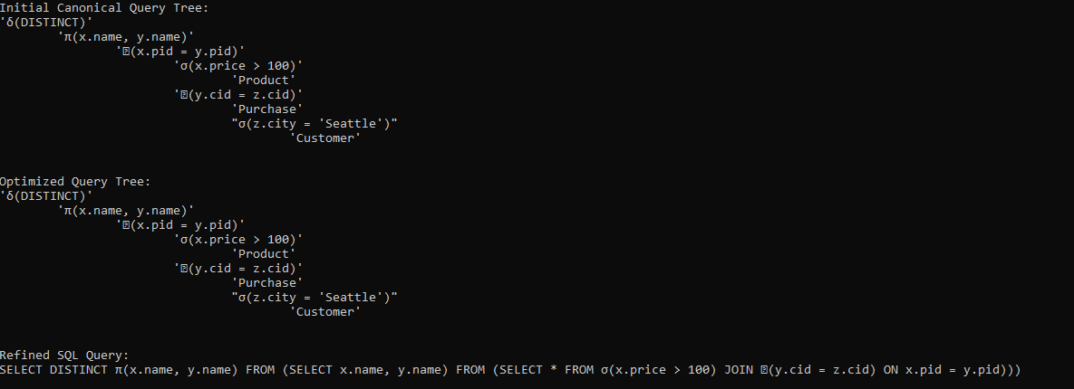

#### Additional Considerations

To further enhance the optimization process, you can incorporate additional inputs such as:

* **Selectivity Estimates:** Information about the selectivity of selection predicates and join conditions to guide the optimizer.
* **Data Distribution Statistics:** Histograms or other statistical data to understand the distribution of attribute values.
* **Index Availability:** Details about available indexes to optimize access paths for queries.